Civil war in Georgia

UNSC Resolution: | 1364
Date of adoption: | 07/31/01
Operative paragraph: | 6
Demand number: | 1364.0611

David Siroky

Wording of demand

accelerate work on the draft protocol on the return of refugees to the Gali Region and measures for economic rehabilitation, as well as on the draft agreement on peace and guarantees for the prevention and for the non-resumption of hostilities

List of addressees of the demand

Government of Georgia, Abkhazia

Short-term compliance

Description of the addressee(s)’ conduct

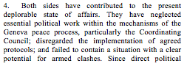

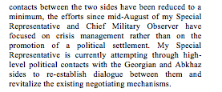

S/2001/1008

S/2001/1008

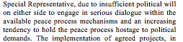

S/2001/1008

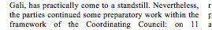

S/2001/1008

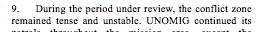

S/2001/1008

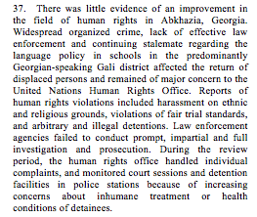

S/2001/1008

Assessment

Short-term compliance
No or marginal compliance (1) | Medium low compliance (2) | Medium high compliance (3) | Full or almost full compliance (4)

Considerations underlying the assessment

Medium-term compliance

Description of the addressee(s)’ conduct

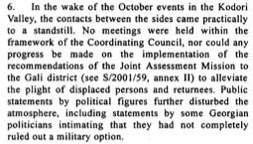

S/2002/88

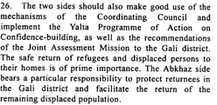

S/2002/88

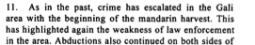

S/2002/88

Assessment

Medium-term compliance
No or marginal compliance (1) | Medium low compliance (2) | Medium high compliance (3) | Full or almost full compliance (4)

Considerations underlying the assessment

Depth of demand

Assessment

Level of depth of demand
Low depth of demand (1) | Medium depth of demand (2) | High depth of demand (3)

Considerations underlying the assessment

Level of confidence about coding decisions

Level of confidence about coding decision
Extremely high | High | Moderate

Comments to IPI (if any)

Civil war in Georgia

UNSC Resolution: | 1364
Date of adoption: | 07/31/01
Operative paragraph: | 7
Demand number: | 1364.0711

David Siroky

Wording of demand

undertake immediate efforts to move beyond the impasse and to engage into negotiations on the core political questions of the conflict and all other outstanding issues in the UN-led peace process (in particular the Abkhaz Side)

List of addressees of the demand

Government of Georgia, Abkhazia

Short-term compliance

Description of the addressee(s)’ conduct

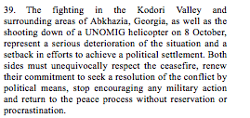

S/2001/1008

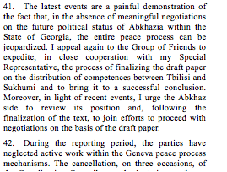

S/2001/1008

Assessment

Short-term compliance
No or marginal compliance (1) | Medium low compliance (2) | Medium high compliance (3) | Full or almost full compliance (4)

Considerations underlying the assessment

Medium-term compliance

Description of the addressee(s)’ conduct

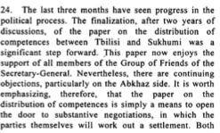

S/2002/88

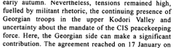

S/2002/88

Assessment

Medium-term compliance
No or marginal compliance (1) | Medium low compliance (2) | Medium high compliance (3) | Full or almost full compliance (4)

Considerations underlying the assessment

Depth of demand

Assessment

Level of depth of demand
Low depth of demand (1) | Medium depth of demand (2) | High depth of demand (3)

Considerations underlying the assessment

Level of confidence about coding decisions

Level of confidence about coding decision
Extremely high | High | Moderate

Comments to IPI (if any)

Civil war in Georgia

UNSC Resolution: | 1364
Date of adoption: | 07/31/01
Operative paragraph: | 8
Demand number: | 1364.0811

David Siroky

Wording of demand

implement the proposals agreed at the Yalta meeting on confidence building in March 2001 (S/2001/242) in a purposeful and cooperative manner

List of addressees of the demand

Government of Georgia, Abkhazia

Short-term compliance

Description of the addressee(s)’ conduct

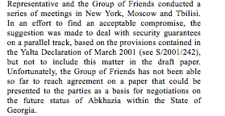

S/2001/1008

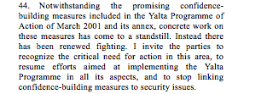

S/2001/1008

Assessment

Short-term compliance
No or marginal compliance (1) | Medium low compliance (2) | Medium high compliance (3) | Full or almost full compliance (4)

Considerations underlying the assessment

Medium-term compliance

Description of the addressee(s)’ conduct

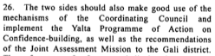

S/2002/88

Assessment

Medium-term compliance
No or marginal compliance (1) | Medium low compliance (2) | Medium high compliance (3) | Full or almost full compliance (4)

Considerations underlying the assessment

Depth of demand

Assessment

Level of depth of demand
Low depth of demand (1) | Medium depth of demand (2) | High depth of demand (3)

Considerations underlying the assessment

Level of confidence about coding decisions

Level of confidence about coding decision
Extremely high | High | Moderate

Comments to IPI (if any)

Civil war in Georgia

UNSC Resolution: | 1364
Date of adoption: | 07/31/01
Operative paragraph: | 9
Demand number: | 1364.0911

David Siroky

Wording of demand

resume work in the Coordinating Council and its relevant mechanisms as soon as possible

List of addressees of the demand

Government of Georgia, Abkhazia

Short-term compliance

Description of the addressee(s)’ conduct

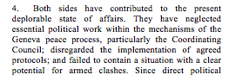

S/2001/1008

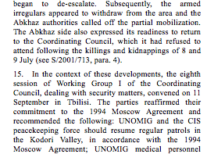

S/2001/1008

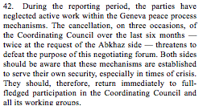

S/2001/1008

Assessment

Short-term compliance
No or marginal compliance (1) | Medium low compliance (2) | Medium high compliance (3) | Full or almost full compliance (4)

Considerations underlying the assessment

Medium-term compliance

Description of the addressee(s)’ conduct

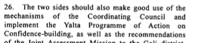

S/2002/88

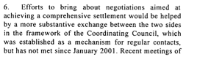

S/2002/469

Assessment

Medium-term compliance
No or marginal compliance (1) | Medium low compliance (2) | Medium high compliance (3) | Full or almost full compliance (4)

Considerations underlying the assessment

Depth of demand

Assessment

Level of depth of demand
Low depth of demand (1) | Medium depth of demand (2) | High depth of demand (3)

Considerations underlying the assessment

Level of confidence about coding decisions

Level of confidence about coding decision
Extremely high | High | Moderate

Comments to IPI (if any)

Civil war in Georgia

UNSC Resolution: | 1364
Date of adoption: | 07/31/01
Operative paragraph: | 10
Demand number: | 1364.1011

David Siroky

Wording of demand

work together, through more effective use of existing arrangements within the Coordinating Council mechanisms, in order to clarify the incidents of 8, 9 and 22 July 2001, bring about the release of the hostages still being held and bring the perpetrators to justice

List of addressees of the demand

Government of Georgia, Abkhazia

Short-term compliance

Description of the addressee(s)’ conduct

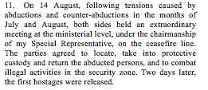

S/2001/1008

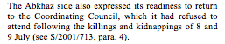

S/2001/1008

Assessment

Short-term compliance
No or marginal compliance (1) | Medium low compliance (2) | Medium high compliance (3) | Full or almost full compliance (4)

Considerations underlying the assessment

Medium-term compliance

Description of the addressee(s)’ conduct

S/2001/1008

Assessment

Medium-term compliance
No or marginal compliance (1) | Medium low compliance (2) | Medium high compliance (3) | Full or almost full compliance (4)

Considerations underlying the assessment

Depth of demand

Assessment

Level of depth of demand
Low depth of demand (1) | Medium depth of demand (2) | High depth of demand (3)

Considerations underlying the assessment

Level of confidence about coding decisions

Level of confidence about coding decision
Extremely high | High | Moderate

Comments to IPI (if any)

Civil war in Georgia

UNSC Resolution: | 1364
Date of adoption: | 07/31/01
Operative paragraph: | 12
Demand number: | 1364.1211

David Siroky

Wording of demand

in the context of op. 11 of the current resolution, address urgently and in a concerted manner, as a first step, the undefined and insecure status of spontaneous returnees to the Gali district, which remains an issue of concern

List of addressees of the demand

Government of Georgia, Abkhazia

Short-term compliance

Description of the addressee(s)’ conduct

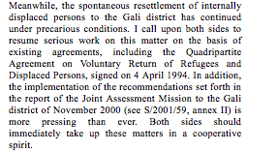

S/2001/1008

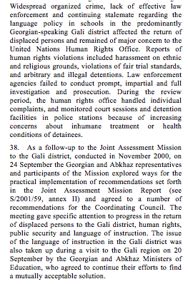

S/2001/1008

Assessment

Short-term compliance
No or marginal compliance (1) | Medium low compliance (2) | Medium high compliance (3) | Full or almost full compliance (4)

Considerations underlying the assessment

Medium-term compliance

Description of the addressee(s)’ conduct

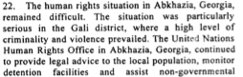
S/2002/88

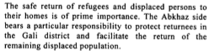

S/2002/88

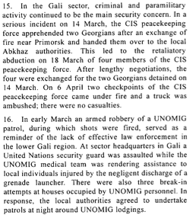

S/2002/469

Assessment

Medium-term compliance
No or marginal compliance (1) | Medium low compliance (2) | Medium high compliance (3) | Full or almost full compliance (4)

Considerations underlying the assessment

Depth of demand

Assessment

Level of depth of demand
Low depth of demand (1) | Medium depth of demand (2) | High depth of demand (3)

Considerations underlying the assessment

Level of confidence about coding decisions

Level of confidence about coding decision
Extremely high | High | Moderate

Comments to IPI (if any)

Civil war in Georgia

UNSC Resolution: | 1364
Date of adoption: | 07/31/01
Operative paragraph: | 16
Demand number: | 1364.1611

David Siroky

Wording of demand

return immediately to full compliance with the Moscow Agreement (S/1994/583 Annex I) which remains a cornerstone of the UN peace effort and ensure the security and freedom of movement of UN and other international personnel

List of addressees of the demand

Government of Georgia, Abkhazia

Short-term compliance

Description of the addressee(s)’ conduct

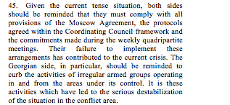

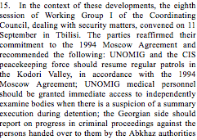

S/2001/1008

S/2001/1008

Assessment

Short-term compliance
No or marginal compliance (1) | Medium low compliance (2) | Medium high compliance (3) | Full or almost full compliance (4)

Considerations underlying the assessment

Medium-term compliance

Description of the addressee(s)’ conduct

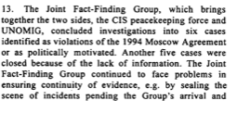

S/2002/88

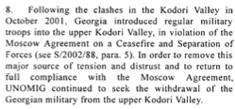

S/2002/469

Assessment

Medium-term compliance
No or marginal compliance (1) | Medium low compliance (2) | Medium high compliance (3) | Full or almost full compliance (4)

Considerations underlying the assessment

Depth of demand

Assessment

Level of depth of demand
Low depth of demand (1) | Medium depth of demand (2) | High depth of demand (3)

Considerations underlying the assessment

Level of confidence about coding decisions

Level of confidence about coding decision
Extremely high | High | Moderate

Comments to IPI (if any)

Civil war in Georgia

UNSC Resolution: | 1364
Date of adoption: | 07/31/01
Operative paragraph: | 17
Demand number: | 1364.1711

David Siroky

Wording of demand

bring to justice the perpetrators of all hostage-taking incidents, particularly the abduction of two UNOMIG military observers in the Kodori Valley on 10 December 2000

List of addressees of the demand

Government of Georgia, Abkhazia

Short-term compliance

Description of the addressee(s)’ conduct

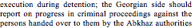

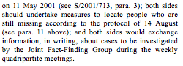

S/2001/1008

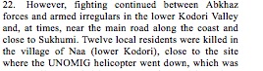

S/2001/1008

Assessment

Short-term compliance
No or marginal compliance (1) | Medium low compliance (2) | Medium high compliance (3) | Full or almost full compliance (4)

Considerations underlying the assessment

Medium-term compliance

Description of the addressee(s)’ conduct

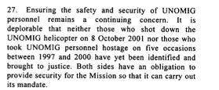

S/2002/88

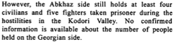

S/2002/88

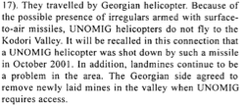

S/2002/469

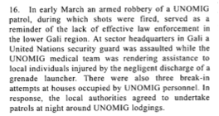
S/2002/469

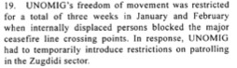

S/2002/469

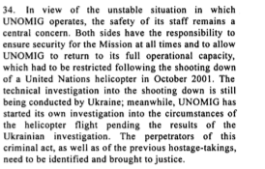

S/2002/469

Assessment

Medium-term compliance
No or marginal compliance (1) | Medium low compliance (2) | Medium high compliance (3) | Full or almost full compliance (4)

Considerations underlying the assessment

Depth of demand

Assessment

Level of depth of demand
Low depth of demand (1) | Medium depth of demand (2) | High depth of demand (3)

Considerations underlying the assessment

Level of confidence about coding decisions

Level of confidence about coding decision
Extremely high | High | Moderate

Comments to IPI (if any)

Civil war in Georgia

UNSC Resolution: | 1364
Date of adoption: | 07/31/01
Operative paragraph: | 18
Demand number: | 1364.1811

David Siroky

Wording of demand

uphold commitment (Georgian side in particular) to put a stop to the activities of illegal armed groups crossing into Abkhazia, Georgia from the Georgian-controlled side of the ceasefire line

List of addressees of the demand

Government of Georgia, Abkhazia

Short-term compliance

Description of the addressee(s)’ conduct

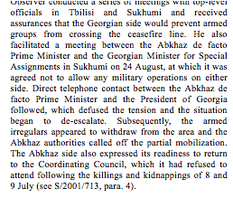

S/2001/1008

Assessment

Short-term compliance
No or marginal compliance (1) | Medium low compliance (2) | Medium high compliance (3) | Full or almost full compliance (4)

Considerations underlying the assessment

Medium-term compliance

Description of the addressee(s)’ conduct

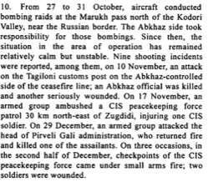

S/2002/88

S/2002/469

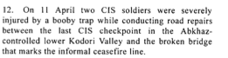

S/2002/469

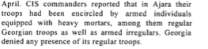

S/2002/469

S/2002/469

Assessment

Medium-term compliance
No or marginal compliance (1) | Medium low compliance (2) | Medium high compliance (3) | Full or almost full compliance (4)

Considerations underlying the assessment

Depth of demand

Assessment

Level of depth of demand
Low depth of demand (1) | Medium depth of demand (2) | High depth of demand (3)

Considerations underlying the assessment

Level of confidence about coding decisions

Level of confidence about coding decision
Extremely high | High | Moderate

Comments to IPI (if any)

